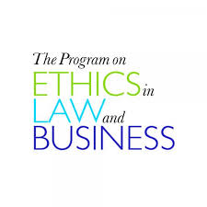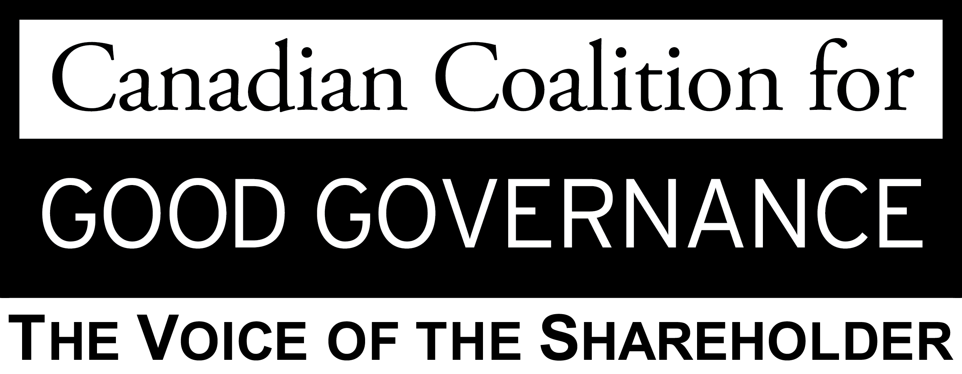
Proxy Access Roundtable

The Centre for the Legal Profession and the Canadian Coalition for Good Governance (CCGG) invite you to attend a roundtable on shareholder access to the proxy from 11:30 am – 2:00 pm on Jan. 29, 2015. In addition to majority voting, the roundtable will examine the director nomination process: why is proxy access important? What is the international context? Should shareholders have the ability to nominate directors? Should shareholders’ nominees be placed on the same ballot as management’s nominees? Should shareholders be required to meet holding period requirements before nominating directors? These questions will form the basis of an in-depth discussion on shareholder access centred around CCGG’s soon to be released proxy access policy.
Speakers List

Welcome and Introductions:
Ed Iacobucci, Dean, Faculty of Law, University of Toronto
Anita Anand, Professor of Law and Academic Director, Centre for the Legal Profession

Speakers:
Stephen Erlichman, Executive Director, Canadian Coalition for Good Governance
Anita Anand, Professor of Law and Academic Director, Centre for the Legal Profession and Faculty of Law, University of Toronto
Stan Magidson, President, CEO and Director, Institute of Corporate Directors
Naizam Kanji, Deputy Director, Corporate Finance, Mergers and Acquisitions, Ontario Securities Commission

Closing Remarks:
The Honourable Henry N. R. Jackman
Cost: $65 (No fee for academics and students however registration is mandatory). This program provides LSUC substantive CPD credits; please calculate and claim your credits based on time attended. To register, please email Allison Hines at allison.hines@utoronto.ca.

